22425840
A)
?CRABS

Results
The crabs data frame has 200 rows and 8 columns, describing 5 morphological measurements on 50 crabs each of two colour forms and both sexes, of the species Leptograpsus variegatus collected at Fremantle, W. Australia.
b)
library(MASS)
data("crabs")
str(crabs)
c)
'data.frame': 200 obs. of 8 variables:
$ sp : Factor w/ 2 levels "B","O": 1 1 1 1 1 1 1 1 1 1 ...
$ sex : Factor w/ 2 levels "F","M": 2 2 2 2 2 2 2 2 2 2 ...
$ index: int 1 2 3 4 5 6 7 8 9 10 ...
$ FL : num 8.1 8.8 9.2 9.6 9.8 10.8 11.1 11.6 11.8 11.8 ...
$ RW : num 6.7 7.7 7.8 7.9 8 9 9.9 9.1 9.6 10.5 ...
$ CL : num 16.1 18.1 19 20.1 20.3 23 23.8 24.5 24.2 25.2 ...
$ CW : num 19 20.8 22.4 23.1 23 26.5 27.1 28.4 27.8 29.3 ...
$ BD : num 7 7.4 7.7 8.2 8.2 9.8 9.8 10.4 9.7 10.3 ...

Freq_Tab_Species<-table(crabs$sp) ##frequency table species
Freq_Tab_sex<-table(crabs$sex) ##frequency table sex

Results
B O
F 50 50
M 50 50
The data is balanced across all the 4 groups. They have similar heights and width

Question 2
a)
?boxplot
boxplot(crabs$BD ~ crabs$sp+sex, data = crabs,
main = "BD Defined by Sex and Species",
xlab = "Species",
ylab = "Body Depth")

outliers <- boxplot(crabs$BD~sp+sex, data = crabs, plot = FALSE)$out ###identifying outliers
outliers

Results
numeric(0)
Th2b) There are no outliers, there seem to be virtually no variabiliyu in the data

3)
?hist
par(mfrow = c(1, 2))
hist(crabs$CL[crabs$sp == "B"],
main = " for Species B",
xlab = "Carapace Length")
hist(crabs$CL[crabs$sp == "O"],
main = "CL for Species O",
xlab = "Carapace Length")

The distributions of the CL for the distributions are both normal (Hence the bell shaped, hence they are both mesokurtic. The distribution peaks around 30mm for B and between 35 to 40 of B.

4)
morph_mean <- aggregate(cbind(FL, RW, CL, CW, BD) ~ sp + sex,
data = crabs, FUN = mean)

## grouped barplot of these means
par(mfrow = c(1, 1))
barplot(t(as.matrix(morph_mean[,-c(1,2)])),
beside = TRUE, legend = TRUE,
main = "Mean Morphological Measurements by Species and Sex",
xlab = "Species and Sex",
ylab = "Mean Value",
names.arg = paste(morph_mean$sp, morph_mean$sex, sep = "-"))

## The greatest species difference and the least sex variation
species_diff <- apply(morph_mean[,-c(1,2)], 2, function(x) max(x) - min(x))
sex_var <- apply(morph_mean[,-c(1,2)], 2, function(x) abs(x[1] - x[2]))
species_diff
sex_var
variation <- apply(morph_mean[,-c(1,2)], 2,
function(x) abs(x[1] - x[2])/species_diff)
Compute the mean of each morpnological
# measurement (FL, RW, CL, CW, BD) by species and sex
morph_mean <- aggregate(cbind(FL, RW, CL, CW, BD) ~ sp + sex,
data = crabs, FUN = mean)
morph_mean

## The greatest species difference and the least sex variation
species_diff <- apply(morph_mean[,-c(1,2)], 2, function(x) max(x) - min(x))
sex_var <- apply(morph_mean[,-c(1,2)], 2, function(x) abs(x[1] - x[2]))
species_diff
sex_var
variation <- apply(morph_mean[,-c(1,2)], 2,
function(x) abs(x[1] - x[2])/species_diff)
variation

Results
sp sex FL RW CL CW BD
1 B F 13.270 12.138 28.102 32.624 11.816
2 O F 17.594 14.836 34.618 39.036 15.632
3 B M 14.842 11.718 32.014 36.810 13.350
4 O M 16.626 12.262 33.688 37.188 15.324

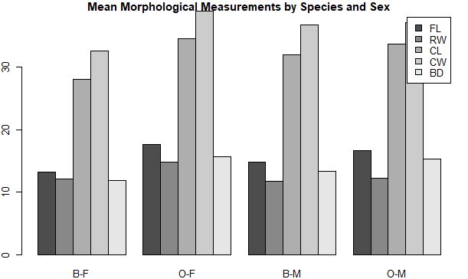

Question 5
pairs(crabs[, c("FL", "RW", "CL", "CW", "BD")],
main = "Scatterplot Matrix of Morphological Measurements",
pch = 19,)

Results

